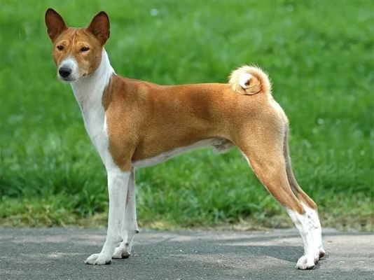

Telomian

* Name: Telomian
* Origin: Malaysia
* Description: Telomians are medium-sized dogs with short, smooth coats. They are known for their agility and climbing ability, as well as their loyalty and intelligence. They are good watchdogs and are excellent with children.
* Key Features:
  + Short, smooth coat
  + Agile and excellent climbers
  + Loyal and intelligent
  + Good watchdogs
  + Excellent with children

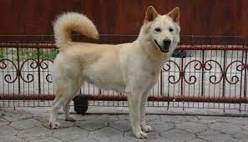

**Kintamani**

* Name: Kintamani
* Origin: Malaysia
* Description: Kintamani dogs are medium-sized spitz-type dogs with thick, double coats. They are known for their intelligence, independence, and loyalty. They are good watchdogs and have a strong hunting instinct.
* Key Features:
  + Thick, double coat
  + Intelligent and independent
  + Loyal and good watchdogs
  + Strong hunting instinct

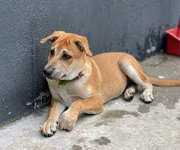

**Kampung Dog**

Name: Kampung Dog (translates as "Village Dog")

* Origin: Malaysia
* Description: Kampung dogs are a type of mixed-breed dog found throughout Malaysia. They are known for their adaptability, intelligence, and loyalty. They are good guard dogs and are generally healthy and low-maintenance.
* Key Features:
  + Mixed breed
  + Adaptable, intelligent, and loyal
  + Good guard dogs
  + Healthy and low-maintenance

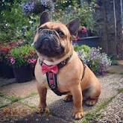

**Malaysian Bulldog**

**O**ther names: Perro Bulldog Malayo Size: Medium Weight: 25-40 kg Height: 50-65 cm Lifespan: 10-12 years

Malaysian Bulldog dog breed

* Description: The Malaysian Bulldog is a muscular, athletic dog with a short, smooth coat. They are known for their intelligence, loyalty, and courage.
* Key features:
  + Loyal
  + Intelligent
  + Courageous
  + Muscular
  + Athletic

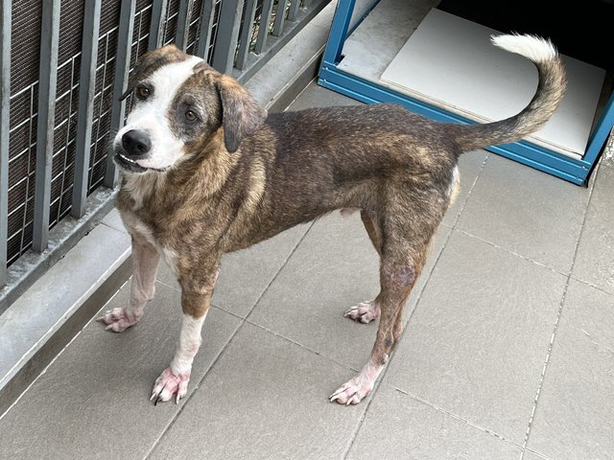

**Kelantan Hound**

Other names: Malay Hound Size: Medium Weight: 15-25 kg Height: 45-55 cm Lifespan: 10-12 years.Kelantan Hound dog breed

* Description: The Kelantan Hound is a slender, agile dog with short, smooth fur. They are known for their excellent sense of smell and their tracking abilities.
* Key features:
  + Excellent sense of smell
  + Tracking abilities
  + Slender
  + Agile

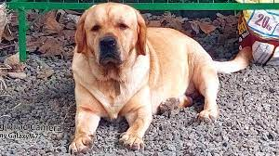

**Javan Retriever**

Other names: Bukittinggi Retriever

Size: Medium

Weight: 20-30 kg

Height: 50-60 cm

Lifespan: 10-12 years

Javan Retriever dog breed

* Description: The Javan Retriever is a strong, muscular dog with short, thick fur. They are known for their intelligence, loyalty, and retrieving abilities.
* Key features:
  + Intelligent
  + Loyal
  + Retrieving abilities
  + Strong
  + Muscular

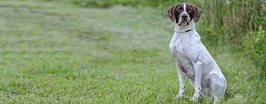

**Malaysian Pointer**

Other names: Malay Pointer Size: Medium Weight: 20-30 kg Height: 45-55 cm Lifespan: 10-12 years

Malaysian Pointer dog breed

* Description: The Malaysian Pointer is a slender, agile dog with short, smooth fur. They are known for their excellent scenting abilities and their pointing abilities.
* Key features:
  + Excellent scenting abilities
  + Pointing abilities
  + Slender
  + Agile

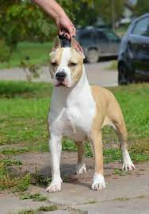

**Borneo Terrier**

Other names: Borneo Silken Terrier Size: Small Weight: 5-10 kg Height: 25-35 cm Lifespan: 10-12 years

Borneo Terrier dog breed

* Description: The Borneo Terrier is a small, terrier-like dog with soft, silky fur. They are known for their intelligence, loyalty, and hunting abilities.
* Key features:
  + Intelligent
  + Loyal
  + Hunting abilities
  + Small
  + Terrier-like

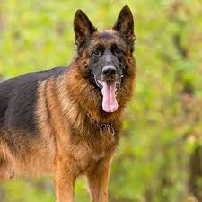

**Malaysian Shepherd**

Other names: Perro Pastor Malayo Size: Medium to Large Weight: 25-40 kg Height: 55-65 cm Lifespan: 10-12 years

Malaysian Shepherd dog breed

* Description: The Malaysian Shepherd is a muscular, agile dog with a medium-length, wavy coat. They are known for their intelligence, loyalty, and herding abilities.
* Key features:
  + Intelligent
  + Loyal
  + Herding abilities
  + Muscular
  + Agile

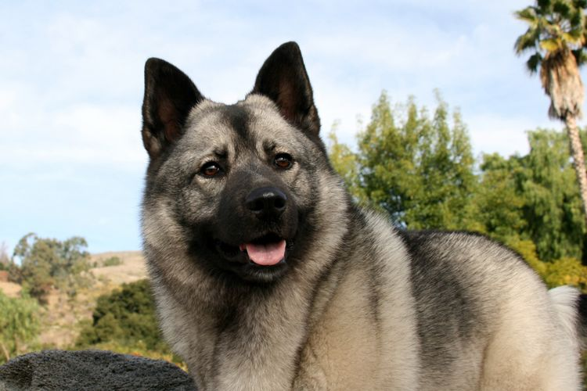

**Rumpun Hutan Dog**

Other names: Malay Forest Dog Size: Medium Weight: 15-25 kg Height: 45-55 cm Lifespan: 10-12 years

Rumpun Hutan Dog breed

* Description: The Rumpun Hutan Dog is a slender, agile dog with short, smooth fur. They are known for their excellent sense of smell and their tracking abilities in the forest.
* Key features:
  + Excellent sense of smell
  + Tracking abilities
  + Slender
  + Agile
  + Forest dog



**Sabah Terrier**

Other names: Borneo Terrier Size: Small Weight: 5-10 kg Height: 25-35 cm Lifespan: 10-12 years

Sabah Terrier dog breed

* Description: The Sabah Terrier is a small, terrier-like dog with soft, silky fur. They are known for their intelligence, loyalty, and hunting abilities in the jungles.
* Key features:
  + Intelligent
  + Loyal
  + Hunting abilities
  + Small
  + Terrier-like

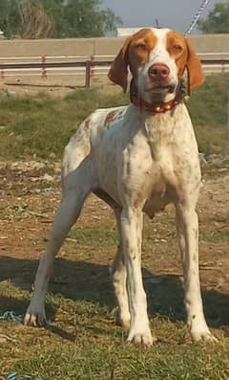

**Selangor Pointer**

Other names: Perro Podenco Selangor Size: Medium Weight: 20-30 kg Height: 45-55 cm Lifespan: 10-12 years

Selangor Pointer dog breed

* Description: The Selangor Pointer is a slender, agile dog with short, smooth fur. They are known for their excellent scenting abilities and their pointing abilities in the fields.
* Key features:
  + Excellent scenting abilities
  + Pointing abilities
  + Slender
  + Agile

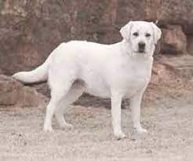

**Sumatran Retriever**

Other names: Perro Retriever Sumatrano Size: Medium Weight: 20-30 kg Height: 50-60 cm Lifespan: 10-12 years

Sumatran Retriever dog breed

* Description: The Sumatran Retriever is a strong, muscular dog with short, thick fur. They are known for their intelligence, loyalty, and retrieving abilities in water.
* Key features:
  + Intelligent
  + Loyal
  + Retrieving abilities
  + Strong
  + Muscular